CSE108 – Computer Programming Laboratory Lab #3
Date: March 6, 2026

Part 0. Structural Requirements
- Nested for/while loops: You are expected to use nested loops (for and/or while) in your solutions for Part 1 and Part 2. As long as each part includes at least one nested loop structure, you are free to use loops in any way you want.
- Loop requirement: You are expected to use at least one while loop, one for loop, and one do-while loop in your .c file. Once you have used each of these loop types at least once, you may use any loop you want.
- Function declaration and call: You are expected to implement a main function and two additional functions that provide the solutions for Part 1 and Part 2. You must declare these two functions at the top of your .c file, define them after the main function, and call them from within the main function.
Main Function Implementation. [10 pts] You are required to write a single C program. The program must display a menu to the user and perform operations based on the selection. The program must run continuously until the user chooses to exit. You are expected to use do-while loop to display the menu. You are also expected to use switch-case structure in your do-while loop.
You will have 3 cases in switch-case structure. First case must call drawSquare(); function for Part 1 solution. Second case must call taylorSeries(); function for Part 2 solution. Third case must print “Exiting program. Goodbye!”, exit the do-while loop, and terminate the main function. You must also handle the default case. It must print “Invalid choice! Please enter 1, 2, or 3.”.

- [40 pts] Drawing a Square: Implement a function to print a square as given below. You must use nested loop structure.
Function Prototype: void drawSquare()
1. Get the number of the rows from the user as an integer.
2. Use a for or while loop to iterate through each row.
3. For each row of the square, you must print a specific number of stars and dots. Use one loop to print the stars, and immediately after that loop, use another loop to print the dots.
Hint: You must find a correlation between the current row number and the number of stars and dots to print in that row.

- [50 pts] Taylor Series Calculation Table: Implement a function to calculate the Taylor Series for the given inputs and print a table.
$$e^{x}≈1+\frac{x^{1}}{1!}+\frac{x^{2}}{2!}+\frac{x^{3}}{3!}+\frac{x^{4}}{4!}+⋯+\frac{x^{N-1}}{\left(N-1\right)!}$$
Function Prototype: void taylorSeries()
1. Get the $x$ and $N$ variables from the user as integers.
2. The outer loop should iterate from $x=1$ to $x=$ number of rows (incrementing by 1) to generate each row of the table. Here, the number of rows is the value entered by the user in Step 1. At the very end of this outer loop, you must print the current row of the table.
3. For each row of the table, the Taylor series is calculated using the given formula above. In the first row, $x$ = 1 and $N$ is the number of terms entered by the user in Step 1. The series is computed with these values and the result is printed. In the second row, $x$ = 2 while $N$ remains the same, and the calculation is repeated. This continues for each subsequent row until $x$ reaches the user-specified limit entered at Step 1.
4. Inside the outer loop, described in Step 2, use another loop to iterate from $n=1$ to $n=N-1$. At the end of this loop, you must obtain the specific element of the series.
5. You can use for or while loops to calculate $x^{n}$ and $n!$ values inside the loop described in Step 4. You can also implement helper functions for this and call them.
6. Sum, power and factorial results must be kept as double. Precision of $e^{x}$ value must be 6.

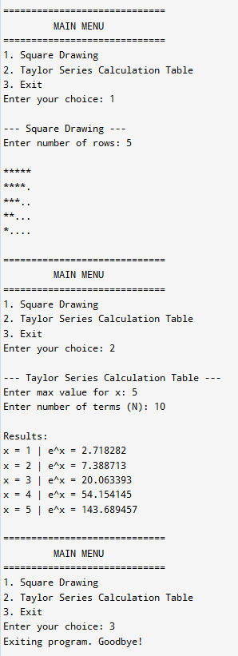 | 

